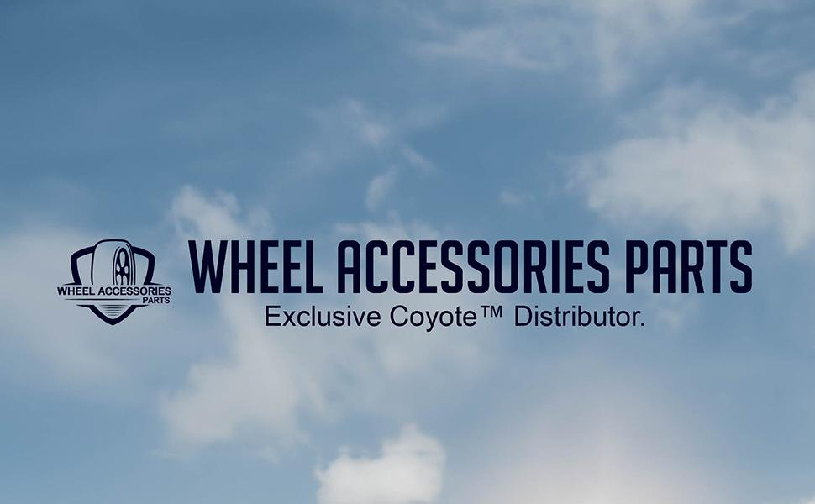
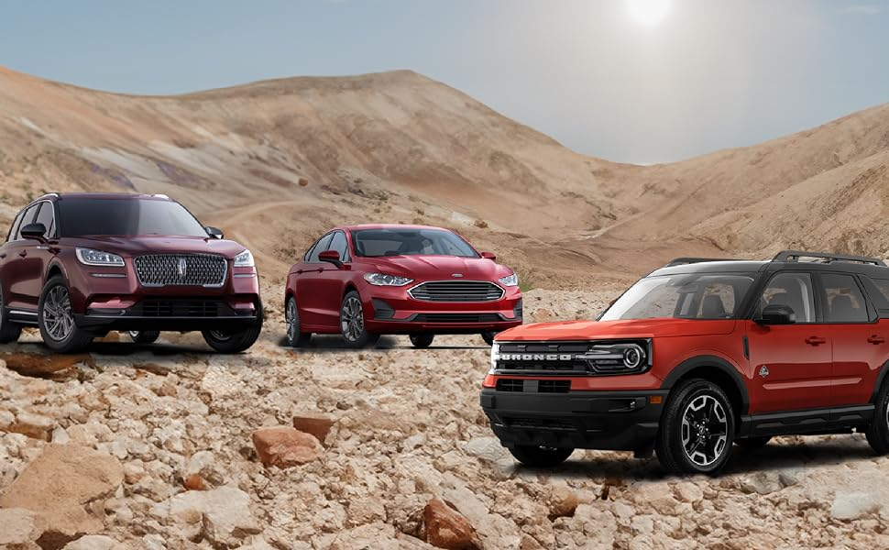

Lug Nuts for Ford and Lincoln Vehicles
Fitment for the following Ford models
- 2021+ Ford Bronco Sport: 2021 Ford Bronco Sport, 2022 Ford Bronco Sport, 2023 Ford Bronco Sport, 2024 Ford Bronco Sport, 2025 Ford Bronco Sport
- 2018-2022 Ford EcoSport: 2018 Ford EcoSport, 2019 Ford EcoSport, 2020 Ford EcoSport, 2021 Ford EcoSport, 2022 Ford EcoSport
- 2021+ Ford Escape: 2021 Ford Escape, 2022 Ford Escape, 2023 Ford Escape, 2024 Ford Escape, 2025 Ford Escape
- 2006-2020 Ford Fusion: 2006 Ford Fusion, 2007 Ford Fusion, 2008 Ford Fusion, 2009 Ford Fusion, 2010 Ford Fusion, 2011 Ford Fusion, 2012 Ford Fusion, 2013 Ford Fusion, 2014 Ford Fusion, 2015 Ford Fusion, 2016 Ford Fusion, 2017 Ford Fusion, 2018 Ford Fusion, 2019 Ford Fusion, 2020 Ford Fusion
- 2021+ Ford Ranger: 2021 Ford Ranger, 2022 Ford Ranger, 2023 Ford Ranger, 2024 Ford Ranger, 2025 Ford Ranger
Fitment for the following Lincoln models
- 2020+ Lincoln Corsair: 2020 Lincoln Corsair, 2021 Lincoln Corsair, 2022 Lincoln Corsair, 2023 Lincoln Corsair, 2024 Lincoln Corsair, 2025 Lincoln Corsair
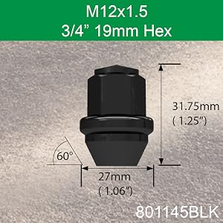

A Precision-Engineered Lug Nut Set
As a US-owned business, we deliver precision-engineered quality you can trust. Your order arrives with a complete set of 20 lug nuts. Designed for OEM wheels. Replaces factory parts CV6Z-1012-C and 611-303.
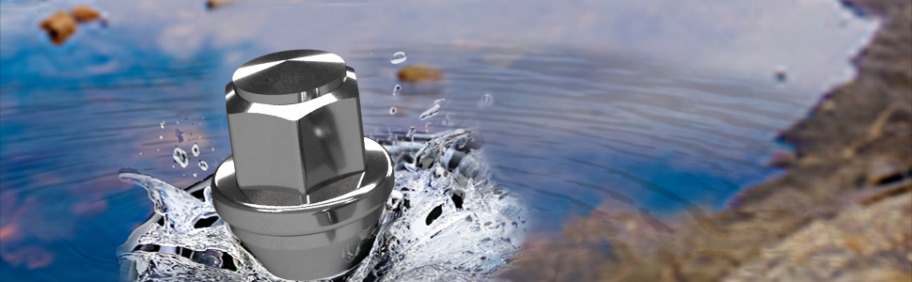

One Piece & 72 Hours Strict Salt Spray Test
Engineered with a superior one-piece construction, our lug nuts outperform and outlast OEM designs. They undergo a rigorous 72-hour salt spray test, guaranteeing exceptional rust and corrosion resistance. This ensures

